Hello Luke,

This is Endy from SwissVite, how are you doing?

I wanted to share my concern, and all the SwissVite partners agree on this one, about the ViteX business model and fees. We're all seasoned crypto traders and confident we can bring valuable feedback. And just like you, we have skin in the game and want Vite to succeed.

First of all, I was a bit surprised to see Vite work on building a DEX from scratch, I think there was initially a plan to use Loopring protocol but that was abandoned. Building a DEX is a very difficult task. Loopring and other projects specializing in DEXs have been working on it full time for 2 years and haven't succeeded yet. I think it would be much better to focus and build on Vite's strength which is a DAG with smart contracts, and free and instant transactions, and promote it as such. There is currently no strong DAG project with smart contracts that is available on the market. I would pour all efforts into releasing the mainnet and smart contracts and advertise use cases which can only be achieved on a DAG and not a regular blockchain. There's not much competition and you guys would take the first-mover advantage!

But ok, fair enough, a DEX can be a nice addition after all, so why not? The issue we see with the proposed implementation for ViteX is that:

- VX's utility looks quite limited besides reducing fees / getting dividends. Why not pay fees directly in Vite?

- The proposed fees (0.5% for both maker and taker) are incredibly high, most markets have a 0.1% fee, usually less for makers, and without having to hold/stake any token.

- Even assuming a trader is a large VX holder - which is a pretty big assumption, he will always choose to have low fees to begin with than hoping to get some of the fees back in the form of dividends in the future.

- The VX distribution curve is way too steep at the beginning (85% of the tokens already released within the first year). This will cause a high selling pressure at the beginning and after a year or two "trading is mining" VX rewards will be very low.

After the rather negative feedback given in that thread <https://forum.vite.net/topic/1170/more-details-about-vitex-economic-model>, I can only guess that Vite management discussed internally and that's why Tony came up with the poll about the fees. I appreciate the effort, but the options offered in the poll are just not good enough. Fees can't be that high, period. Even if Vite managed to release a fully functional DEX soon, what would convince traders to switch away from the exchanges they currently use? ViteX will need at least a better UI/UX and lower fees, why else would someone switch from their usual exchange to ViteX?

0.1% to 0.15% fees are standard, so that should be the default fee. Then holding VX would make this lower or give cashback at the end of the week/month.

I made that small table as a quick reminder, with the three most successful DEX and showing how Binance's low fees blew former top altcoin exchanges Poloniex and Bittrex completely out of the water.

Let's make the comparison with successful exchanges having their own token for fees. Binance/Kucoin/Bibox have fees lower than 0.1% if you pay fees with their token, and you get the dividends on top of that. But the lowest option offered in Tony's poll is 0.4% without VX (yes, four times 0.1%) and 0.25% with VX (over three times...).

Now if we compare ViteX with the three leading DEX, which are more relevant for comparison, they have even lower fees.

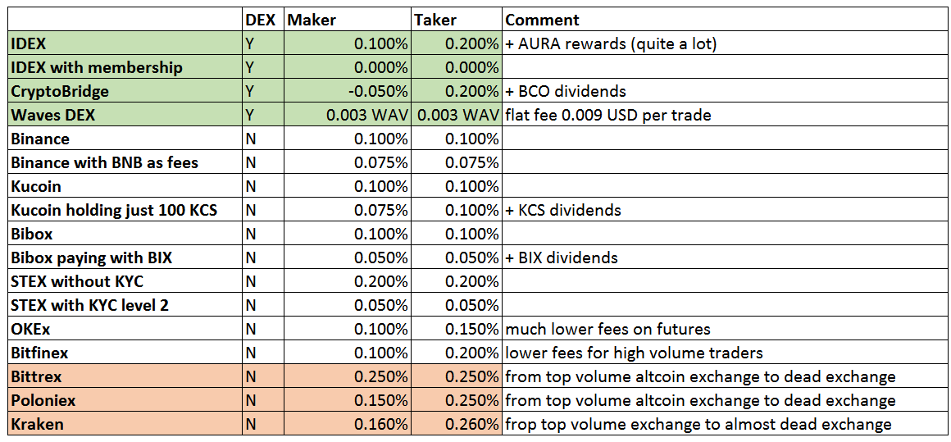

I also strongly suggest offering cheaper fees for makers than for takers if you want to achieve a good liquidity.

Now back to the roadmap, there's a feature we'd love to see being advertised because of its high added value. I can a killer feature, VNS (Vite Name Service) which was announced for the test net release (for reference: <https://medium.com/vitelabs/testnet-1-0-0-is-formally-launched-f0e6295f7ad6>). As far as I know, this is not actually available on the test net? Having human-readable addresses instead of random strings is the perfect example of a must-have feature for a wide-scale adoption, and one the reason that made me a Vite believer and find co-founders for SwissVite.

Another we'd like to see a bit more activity amongst the SBPs. If we look at EOS and Tezos, it is evident that a DPoS project needs a thriving community of SBPs. SwissVite is pretty much the only one participating in the weekly and monthly proposal. That's probably another point to work on, it would look weird to have only one or two active SBPs for the mainnet launch. Maybe increasing the proposal rewards is an option.

To make things clear, we have no doubt about Vite team's capabilities. The Vite testnet is really smooth, I love the speed and free transactions, and the web wallet is one of the best amongst all crypto projects.

Feel free to let us know if you want to discuss this further over a Skype call. Once again, the SwissVite team is composed of experienced miners, traders, graphic designers and coders and both ViteLabs and SwissVite are in the same boat, so let's make something cool!

Cheers

endy